Part 1
Questions 1 to 8
Read the text carefully in each question. Choose the best answer A, B, or C.
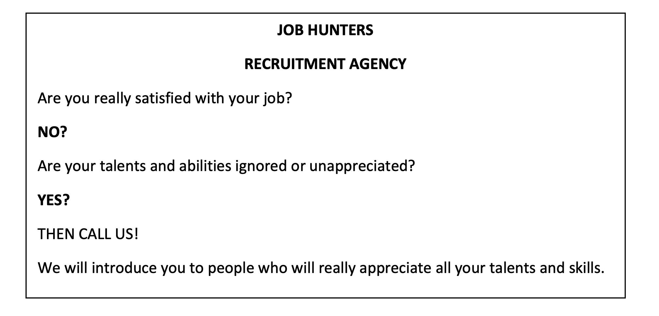
1 What does this advertisement promise?
A A more suitable job for your abilities
B Talented customers for your business
C A promotion in your present job

2 What items are offered for sale in the following advertisement?
A some private collections of porcelain
B some exclusive antiques
C some modern porcelain works
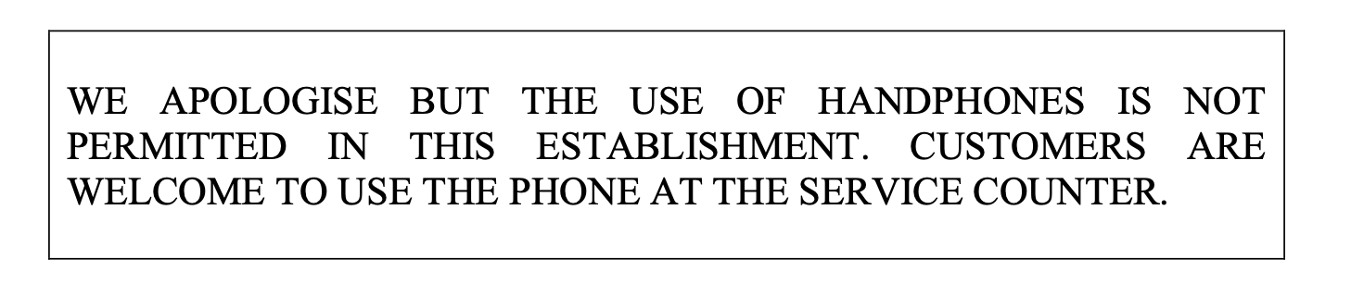
3. Which of the following sentences best explains the signs below?
A Customers can request to use the establishment’s handphones.
B Customers have to use their own handphones in this establishment.
C Customers have to switch off their handphones inside this establishment.

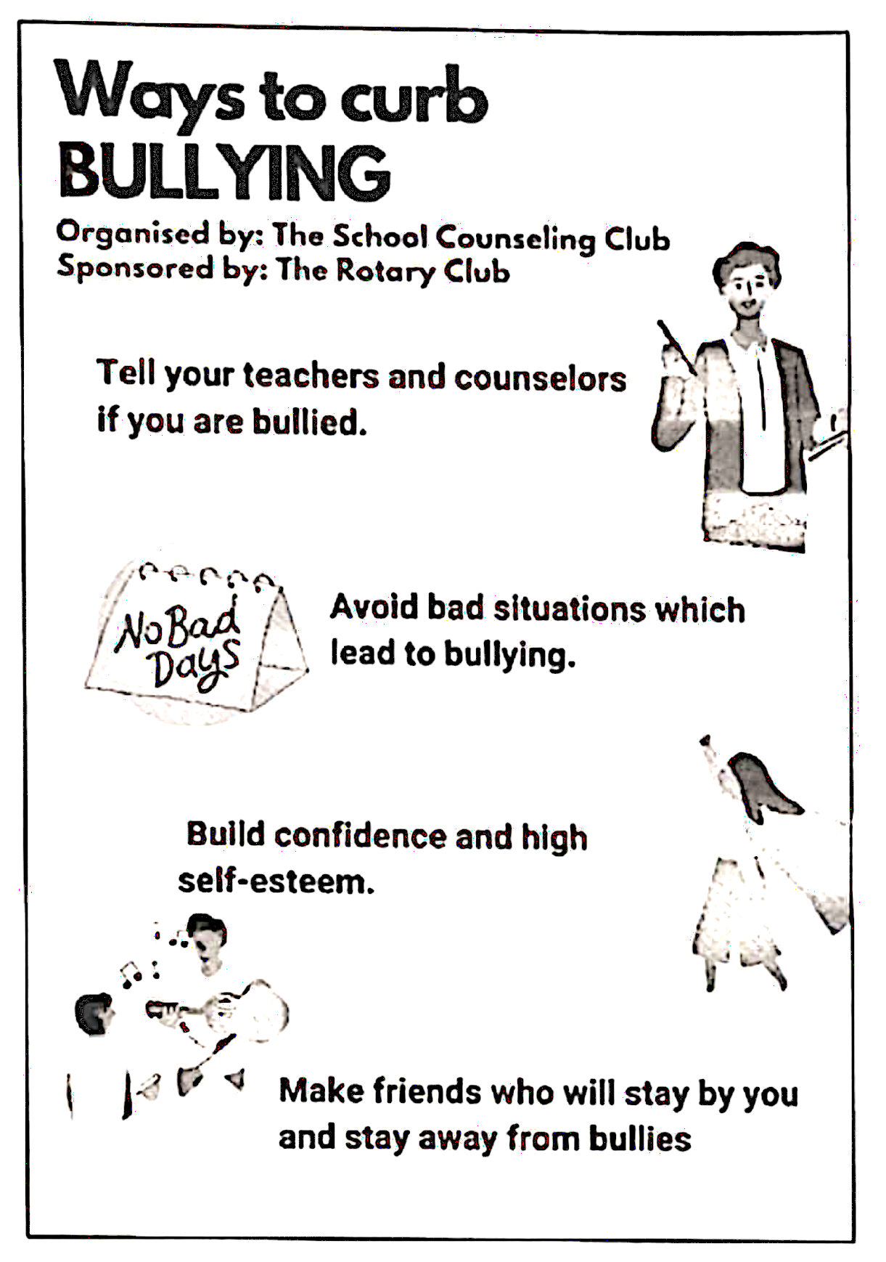 | 4 Which of the following statements is true?  A You have to keep the bully  incident to yourself  B You can stop bullying if you make  friends with the bullies  C The anti-bullying campaign is  financially supported by the Rotary  Club
 | 5 Which of the following statements is true about internet love scam crime?  A The scam does not necessarily  involve money  B The victims are more common  among women  C Internet love scam is a threat for  both men and women alike

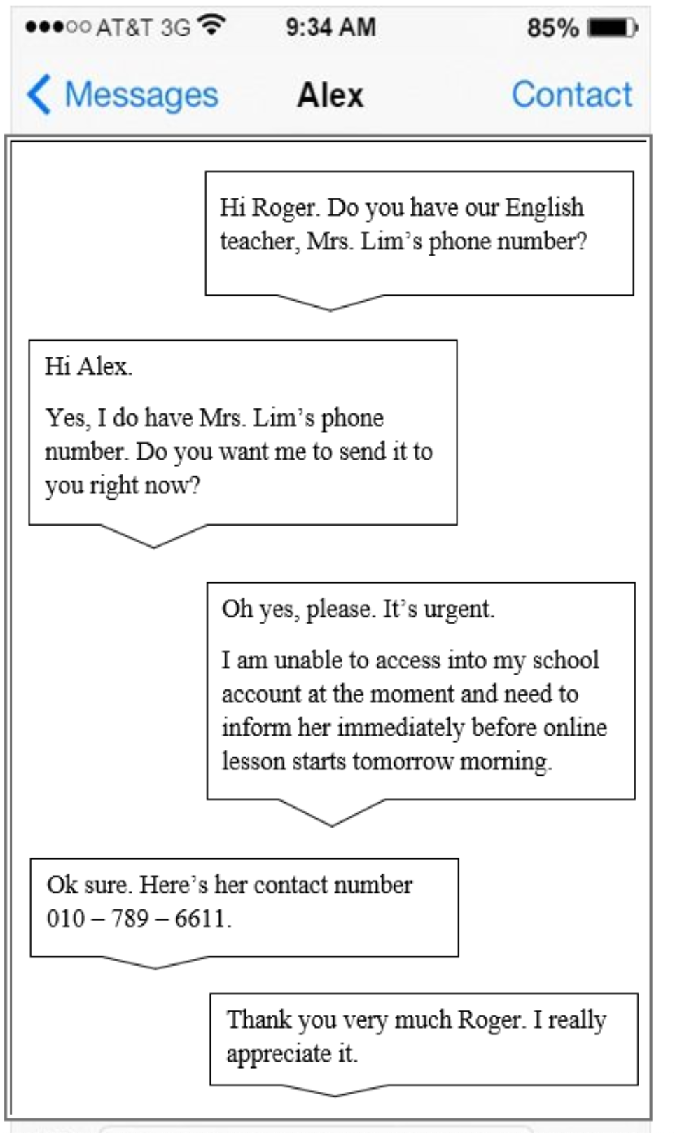 | 6 From the text above , Alex urgently needs Mr. Lim’s phone number because  A he wants to have a talk with her about  the online lesson  B he wants to inform Mrs. Lim about the  technical issues he is currently facing  C he wants Mrs. Lim to help him log in to  his account for the online lesson
 | 7 Based on the advertisement above, which of the following statements is true?  A School leavers are encouraged to apply  for the account clerk post.  B Applicant must have work experience to  qualified for the post.  C Accounting software and databases  trainings will be provided for all the  applicants.

.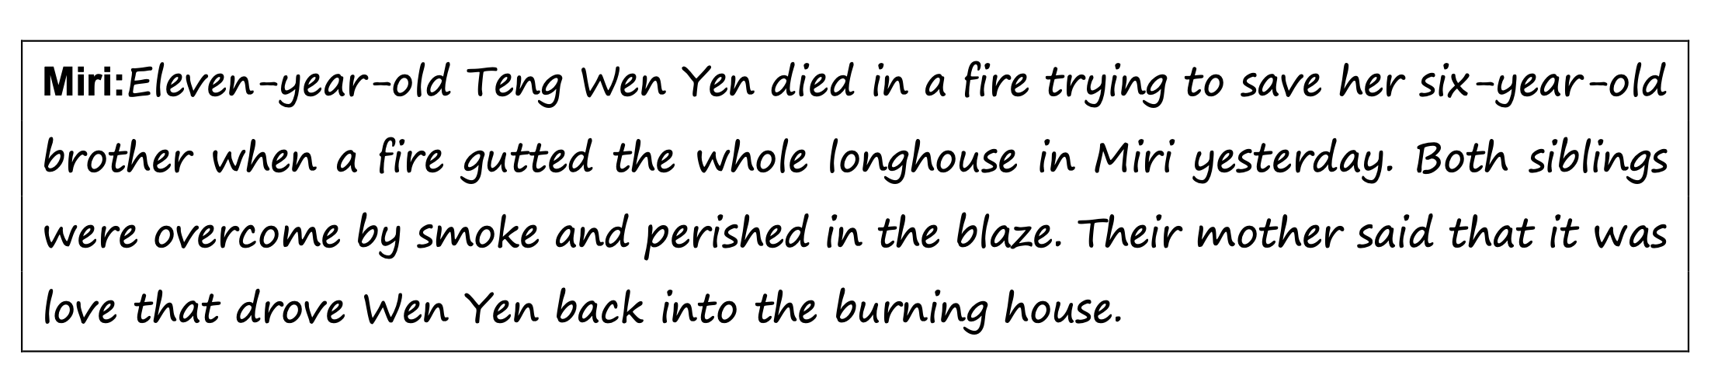
8 From the news report, we know that the

A fire caused several deaths
B mother of the girls worked in Miri
C older sister made a brave attempt to save her brother

Part 2
Questions 9 to 18
Refer to the text below and choose the best word for each space. For each question, mark the correct letter A, B, C or D.
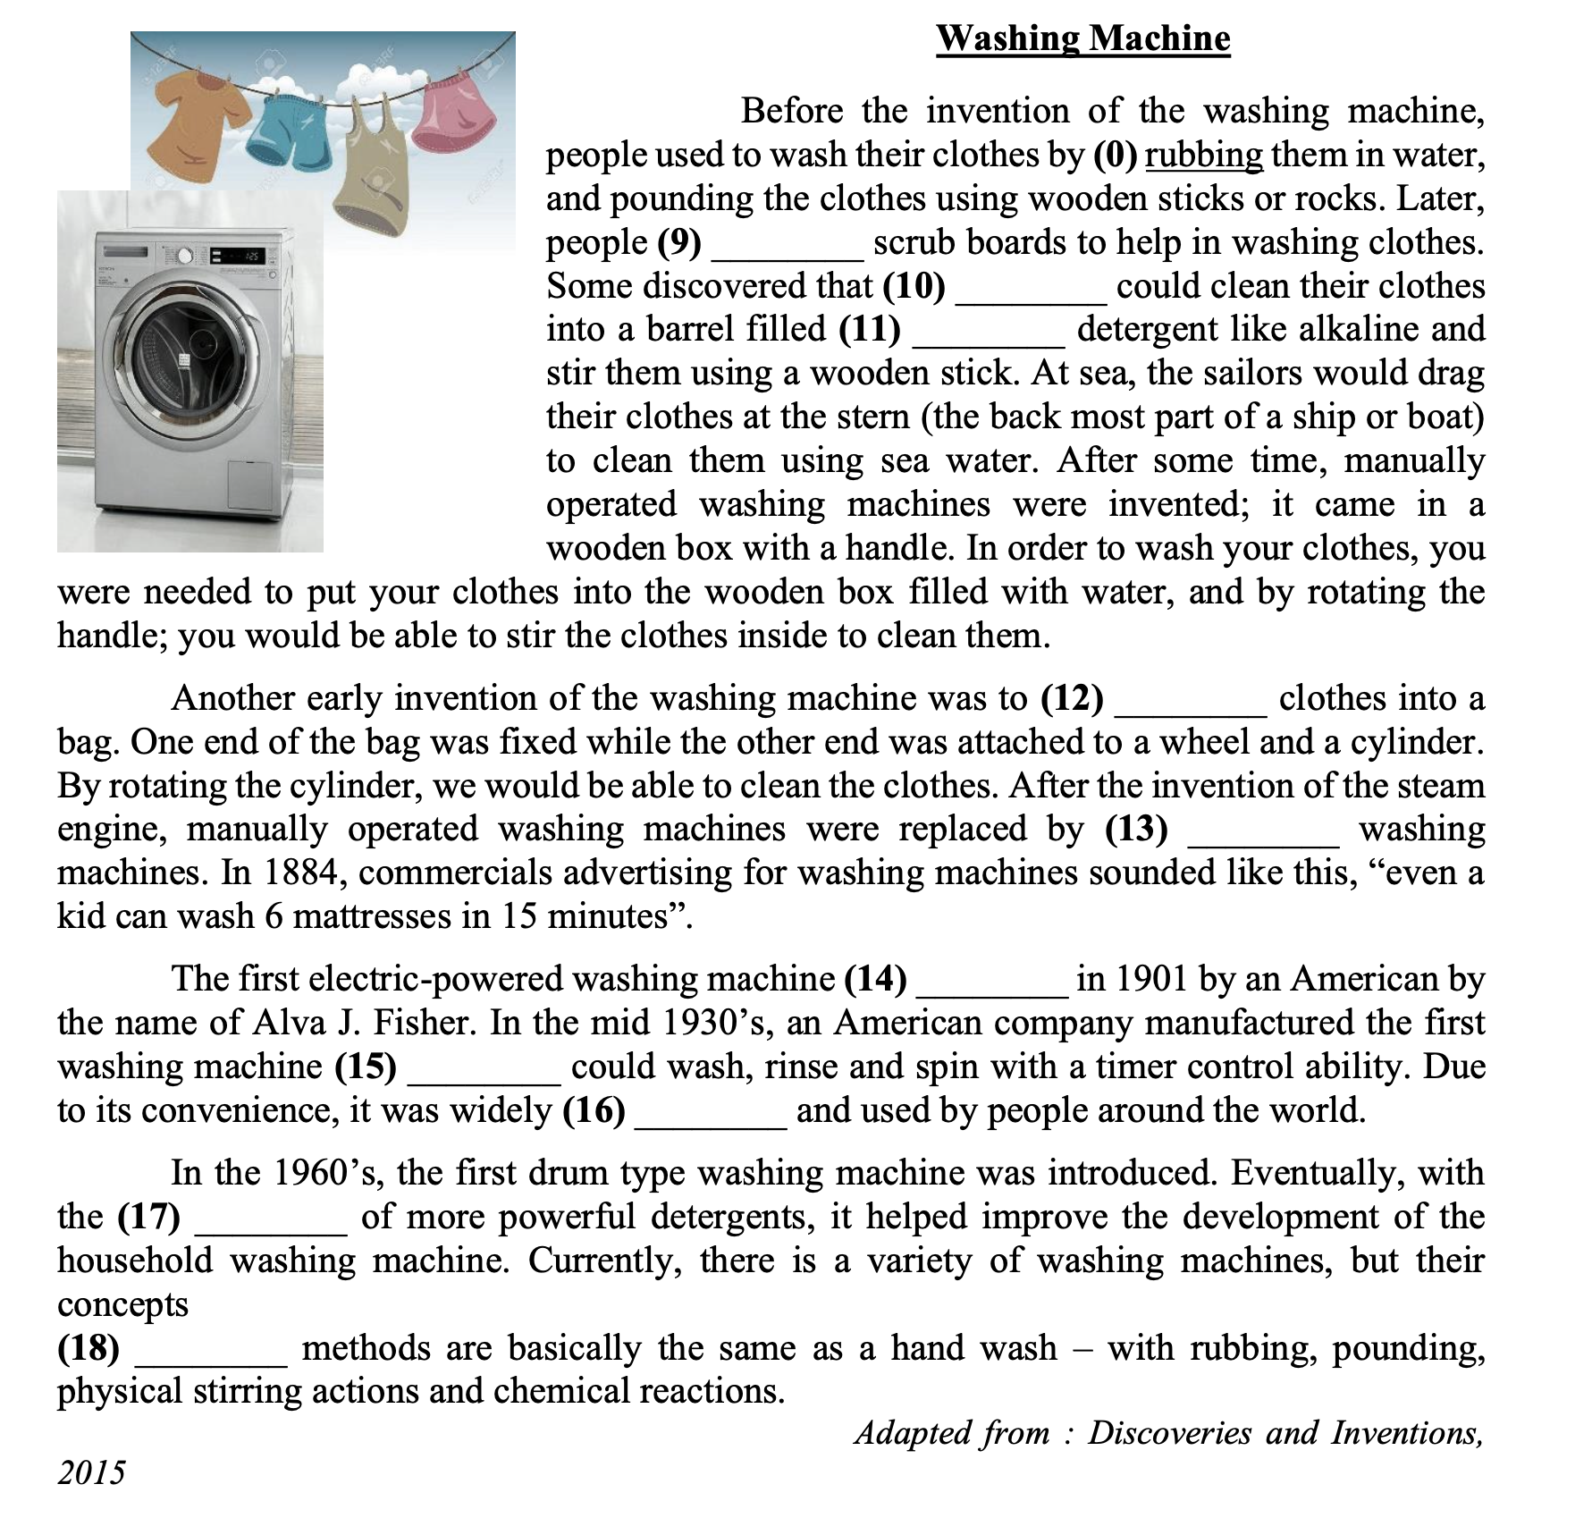
0 | A rub | B rubbed | C rubbing | D has rubbed
9 | A invent | B invented | C inventing | D has invented
10 | A they | B she | C he | D I
11 | A over | B with | C under | D between
12 | A have put | B putting | C puts | D put
13 | A automated | B automatically | C automobile | D automatic
14 | A invented | B is invented | C was invented | D was inventing
15 | A which | B whose | C where | D when
16 | A accepted | B has accepted | C accepts | D accept
17 | A inversion | B creator | C invention | D origination
18 | A or | B if | C but | D and

Part 3
Questions 19 to 26
You are going to read an extract from an article. For questions 19 to 26, choose the correct answer (A, B, C or D) and mark the correct letter A, B, C or D on your answer sheet.

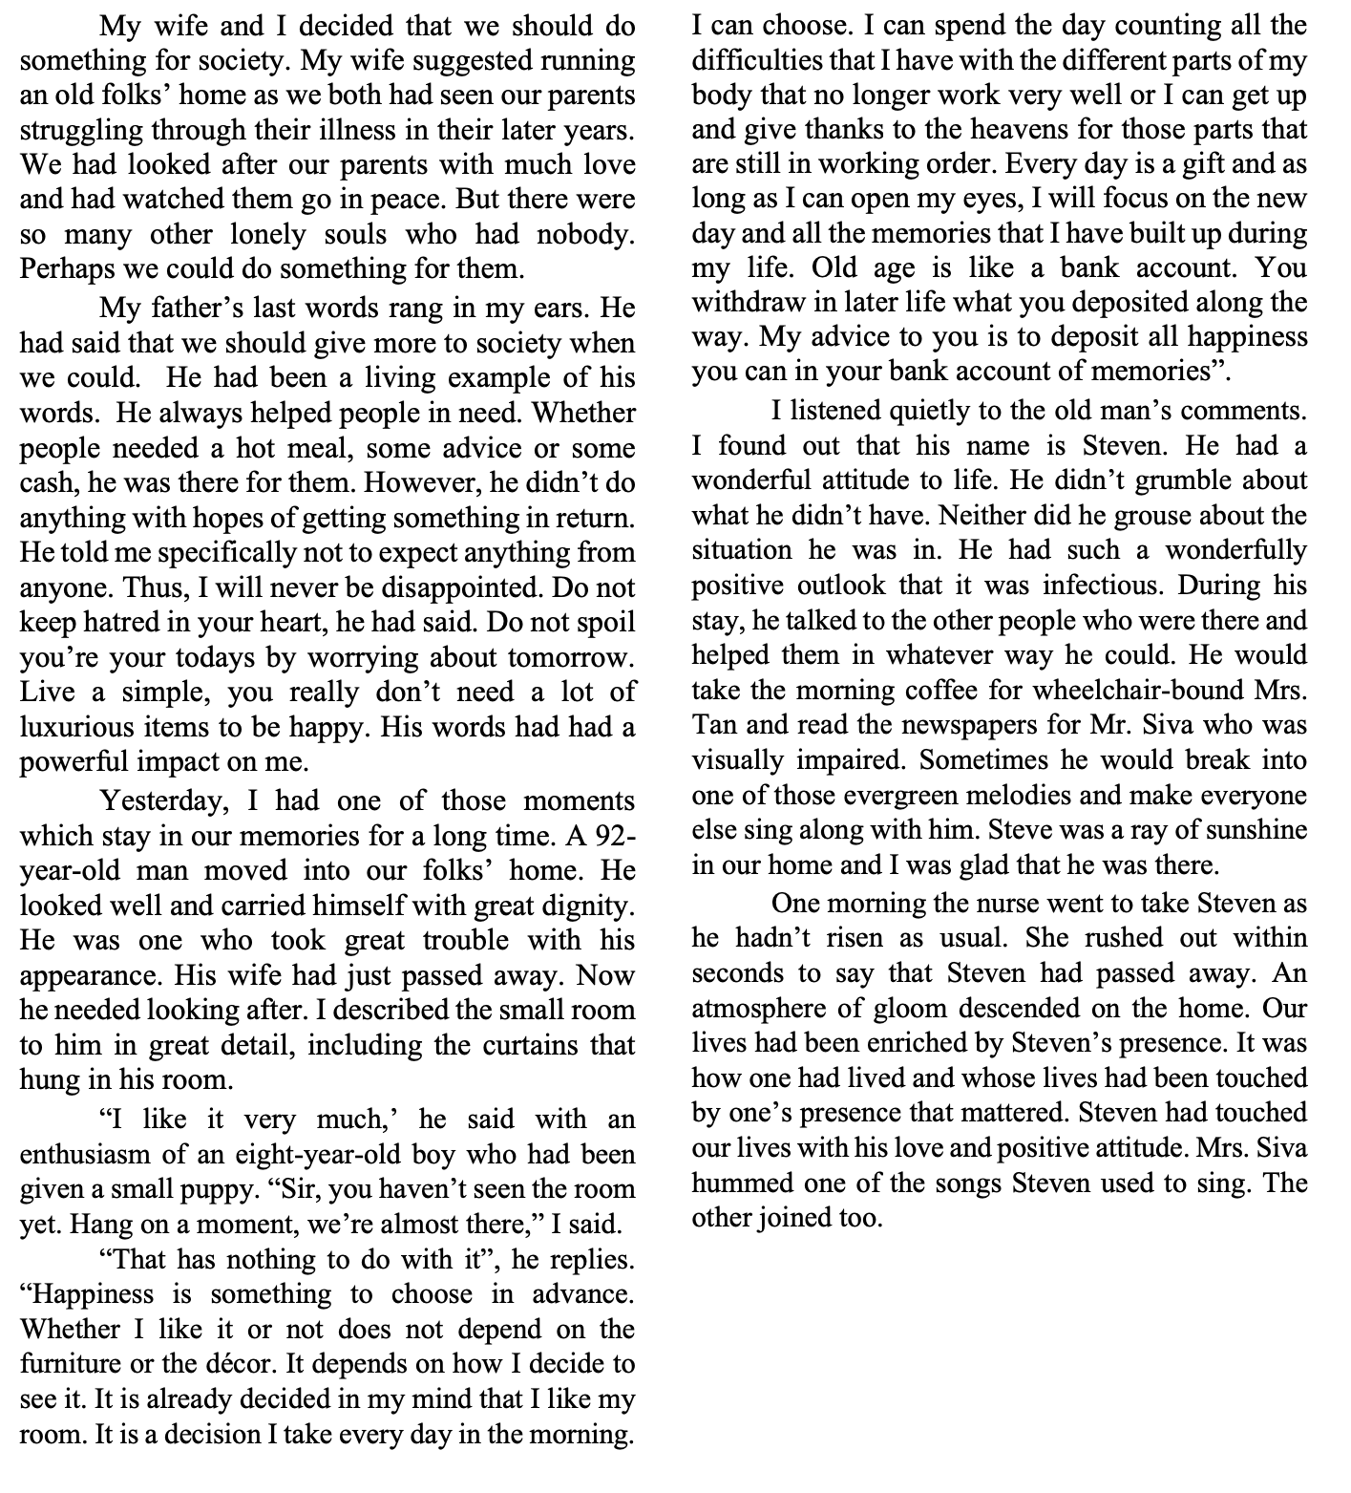

19 From paragraph 1, why did the writer decide to start an old people’s home?
A Many parent struggles with illness.
B He wanted to help his ageing parents.
C He wanted to help society move forward.
D There were many people who had no help.

20 In paragraph 2, the phrase living example can best be replaced with ..
A icon
B model
C clone
D match
21 When would the writer not be disappointed?
A When he leads a simple life
B If he doesn’t expect any repayment.
C If he doesn’t have great hopes for tomorrow.
D When he doesn’t always hold hatred in his heart.

22 From paragraph 3, we know that the 92-year-old man
A needed help in walking.
B had lost his wife years ago.
C held himself with respect.
D was very independent.
23 From paragraph 5, what does the old man’s response regarding his room say about his character?
A He is positive minded.
B He is quick with his judgement.
C He sees things in a light manner.
D He hopes things work to his benefit.

24 Which of the following phrases identifies Steven’s attitude to his later years?
A “as long as I can open my eyes”.
B “memories that I have built up”.
C “that no longer work very well”
D “give thanks to the heaven”.

25 From paragraph 7, which of the following phrases does not show his ‘wonderfully positive outlook?
A he didn’t grouse
B he didn’t grumble
C he didn’t sing
D he helped them in whatever way

26 In the last paragraph, we know that the main point is
A Steven had passed away.
B there was gloom in the home.
C Mr Siva sang one of Steven’s songs
D Steven enriched the lives of the people.
Part 4
Questions 27 to 32
You are going to read an article about a healthy Lifestyle for the first time. Six sentences have been removed from the article.

Choose from the sentences A to H the one which fits each gap (27 to 32). There are two extra sentences which you do not need to use. Mark your answers on the separate answer sheet.

Teens Saving the Environment
16-year-old Nadav Ossendryver is the creator of Kruger Sightings, a website that follows wildlife such as lions, rhinos, elephants, giraffes and leopards in Kruger National Park in South Africa. (27) ________ . Nadav now collects information provided by visitors to Kruger National Park, who use their mobile phones to send updates to Kruger Sightings when they see one of the park’s many animals. (28) _______ . The site also does its best to protect rhinos from people who want to kill them for their valuable horns, which is a growing problem at the park. It provides visitors with contact numbers to report such incidents.
Plastic is useful because it is strong and it lasts a long time. (29) _________ . With 500 billion plastic bags being made every year and the Great Pacific Garbage Patch growing bigger by the day, we clearly need a way to make the plastic break down faster. In 2009, that’s exactly what 16-year-old student Daniel Burd did. (30) _________ . He experimented with the bacteria at different temperatures and managed to break down 43 per cent of the plastic in only six weeks, a major scientific breakthrough.
In 2010, the US produced 2.4 million tons of e-waste, with a huge amount of that being mobile phones. Jason Lin, a 15-year-old high school student, learnt about this problem at school and set up a business to reduce e-waste by keeping old gadgets out of landfills. (31) ________ . People sell their old gadgets to Lin; he and his team then fix them and resell them online. Although there are good e-cyclers like Lin, some just ship the waste to other countries. (32) ________ . With iReTron, consumers make money on their gadgets, iReTron makes a profit and electronics don’t end up in a landfill.

A | Now, however, we do, so there is no excuse for continuing the destruction.
B | The website started as a blog where Nadav wrote about the best places to see the animals.
C | Unfortunately, those qualities also make plastic a disaster for the environment because it takes 1,000 years for these man-made material to break down.
D | In 2011, he took the US to court for not doing enough to protect the atmosphere for future generations.
E | This lets other visitors find the animals more easily.
F | He and his friends run an e-waste recycling business from their website iReTron.com.
G | There, it becomes an environmental and health risk, creating deadly conditions wherever it

Part 5
Question 33 -40
The statements below are about five people and the places they visited. Read the text below and answer all the questions that follow.

Travelling Around the World
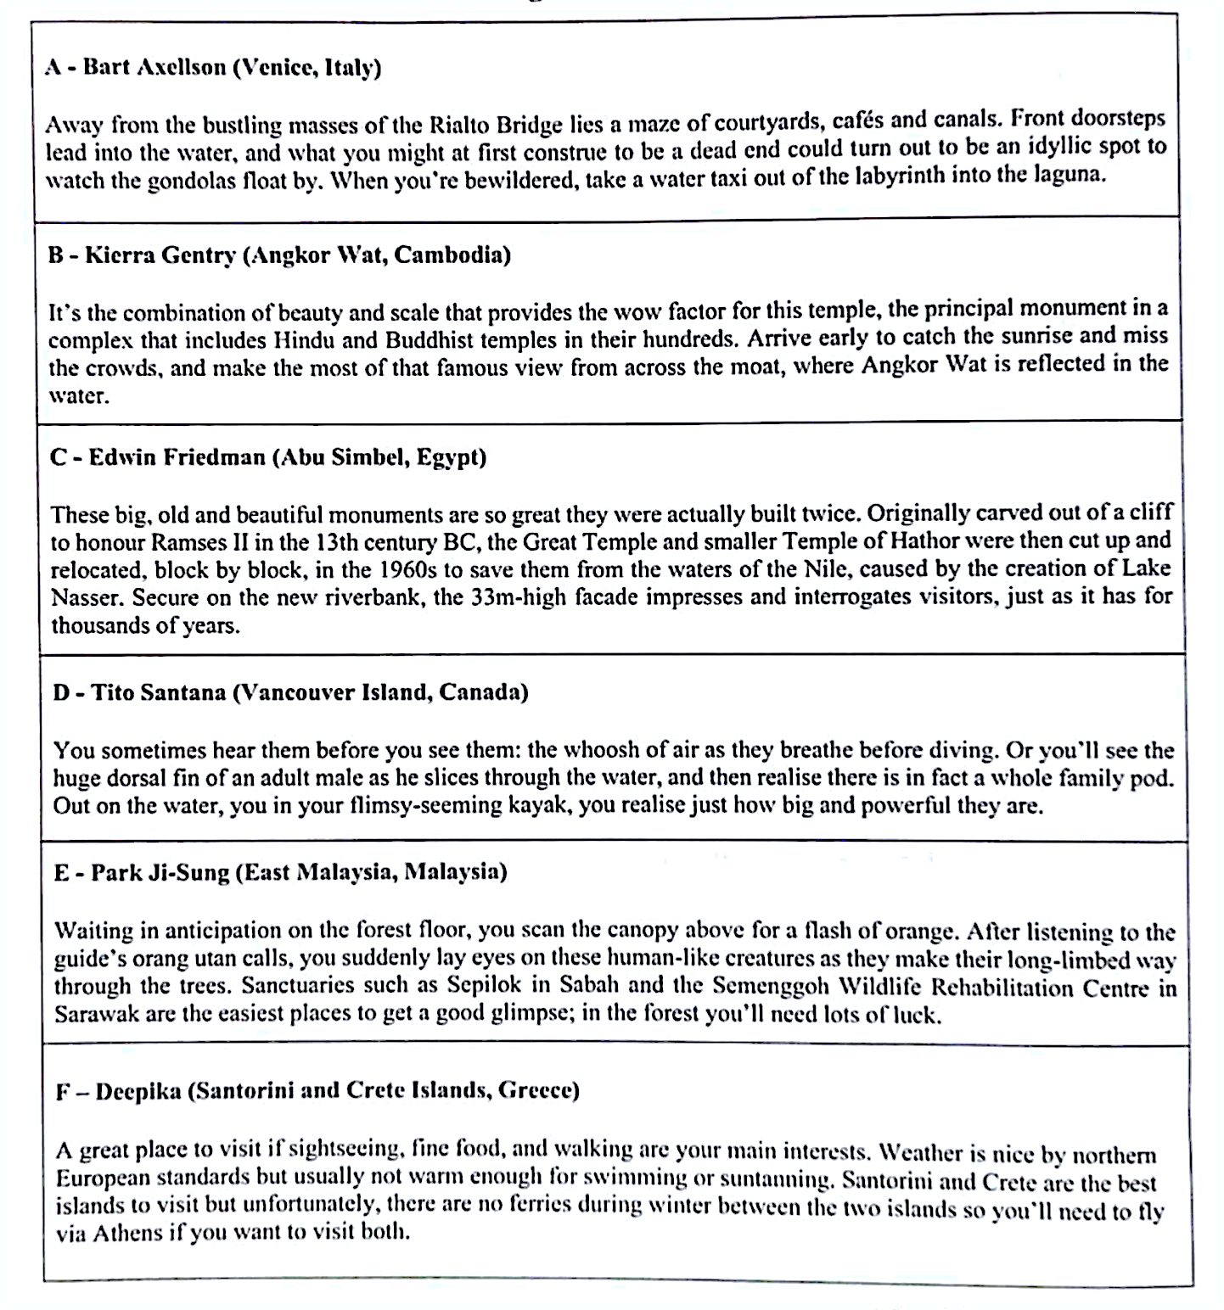
Adapted from wanderlust.com
Questions 33 to 36

Which paragraph (A - F) describes the following statements of tourist attractions?
Mark your answers on the separate answer sheet

 | Statements | Paragraph
33 | This place gives you an opportunity to get up close with marine life
34 | The monuments were rebuilt to save them from natural disaster
35 | The places where animals arc conserved.
36 | It is one of the biggest religious complexes in the world.

Questions 37 to 40
Complete the notes below using information from the text. Choose no more than one word

from the passage for each answer.
Mark your answers on the separate answer sheet.

What We Know About Globetrotting

- Visiting Venice is like you are in a (37) and will easily get lost.

- When visiting temples, the (38) of the area is so vast that sometimes it will take half a day to cover.

- Orcas swim to the surface to (39) before getting back into the water.
- We are able to get a (40) of wildlife by visiting their natural habitat.

END OF QUESTIONS

